A1356-Mex-Olmec-Were Jaguar-Maskette Pendant-Amphibolite-1200-900 BCE

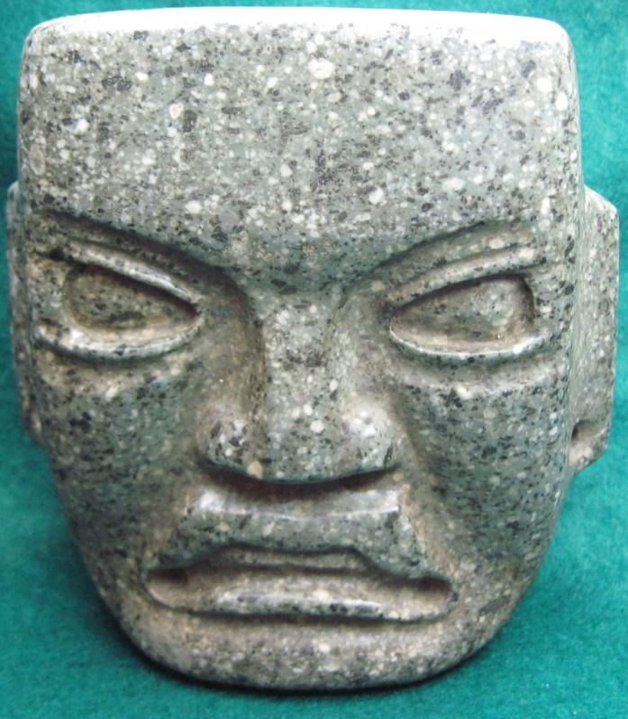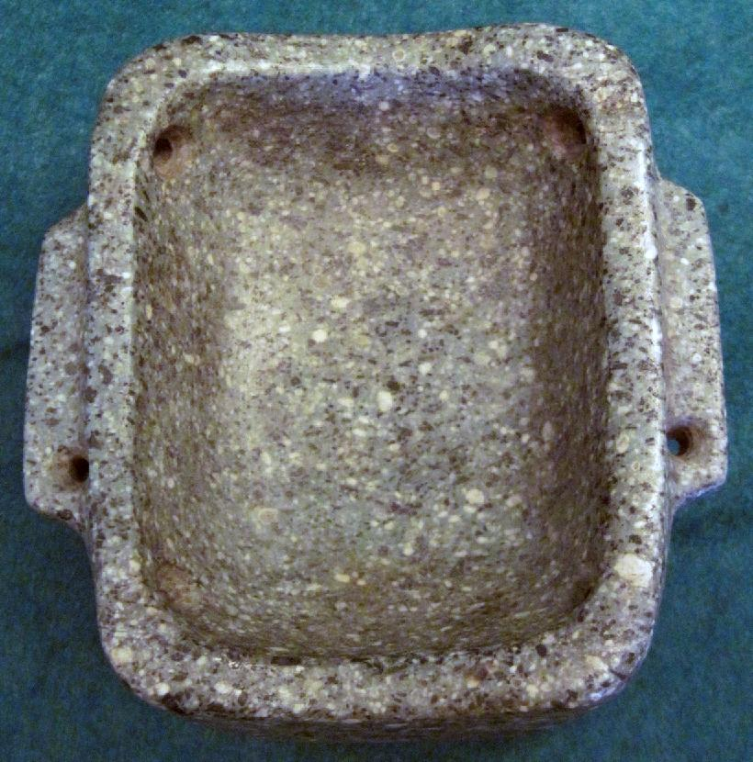

Formal Label: Olmec-Were Jaguar-Maskette Pendant-Amphibolite-1200-900 BCE

Accession Number: A1033

**Display Description:**

This Olmec Were Jaguar maskette pendant dates to the Late Classic period 1200-900 BCE.

The maskette is carved from grey-greenish amphibolite composed of amphibole dark colored prismatic crystals (with interlocking chains of silicate tetrahedra) and plagioclase feldspars. It is typically dark-colored and heavy, with small flecks of black and white giving it a salt-and-pepper appearance.

The maskette features a rigidly rectilinear portrait of a shaman being transforming into a jaguar spirit. He has a flared anthropomorphic nose but has an up-curved upper lip which is intended to emulate the jaguar's snarl, and he bares a row of evenly filed human teeth. Four bi-conical perforations, two drilled into the temples and two drilled into the cheeks, indicate that this was to be worn as a pendant on the chest. Two additional holes were drilled into the ear lobes to suspend gold earrings.

**LC Classification:** F1219

Date or Time Horizon: 1200-900 BCE

Geographical Area: Cuautla, Morelos, Mexico

**Map:**

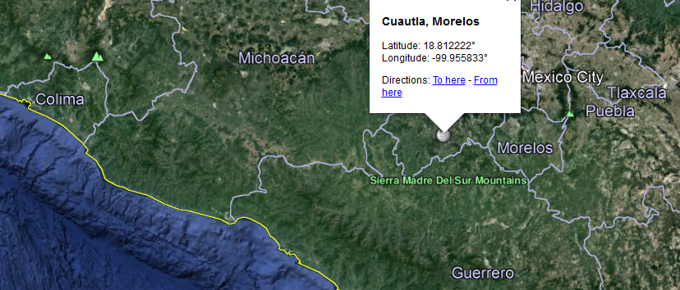

**GPS coordinates:** [18°48′44″N 99°57′21″W](https://tools.wmflabs.org/geohack/geohack.php?pagename=Cuautla,_Morelos&params=18_48_44_N_99_57_21_W_region:MX_type:city)

Cultural Affiliation: Olmec

Medium: Amphibolite

Dimensions: H 4 in, W 3 5/8 in, D 1 5/8 in

Weight:

Condition: original

Provenance: Veracruz, Mexico

**Discussion:**

The recessed eyes under high-arching brows may have been inlaid (with obsidian, conch, etc.) at one time to produce a visage at once powerful and terrifying. However, there is a noticeable beveled lower edge of the eyes that may also signify they were mean to be seen as as they are as though peering down on their on-looking subjects.

**Reference:**

Furst, P.T., 1968. *The Olmec were-jaguar motif in the light of ethnographic reality* (No. 8). Univ. of California.

**Appendix:**

A similar, rigidly rectangular maskette effigy maskette from Cuautla, Morelos, Mexico, is in the University of Maine Museum.